Site Visit Report completed by Ryan Odegaard.
On 6/9/2021 I met with Mr. Patron and his son, Rio Patron, at the home address of the violations. The time of the meeting was approximately 1005 hours. I was granted permission to come on to the property to take photos of the property to evaluate the status of the home. During my visit I was accompanied by CRT Representatives Staveskie and Hossienzadeh. Mr. Patron and/or Rio Patron were always with me during my visit.
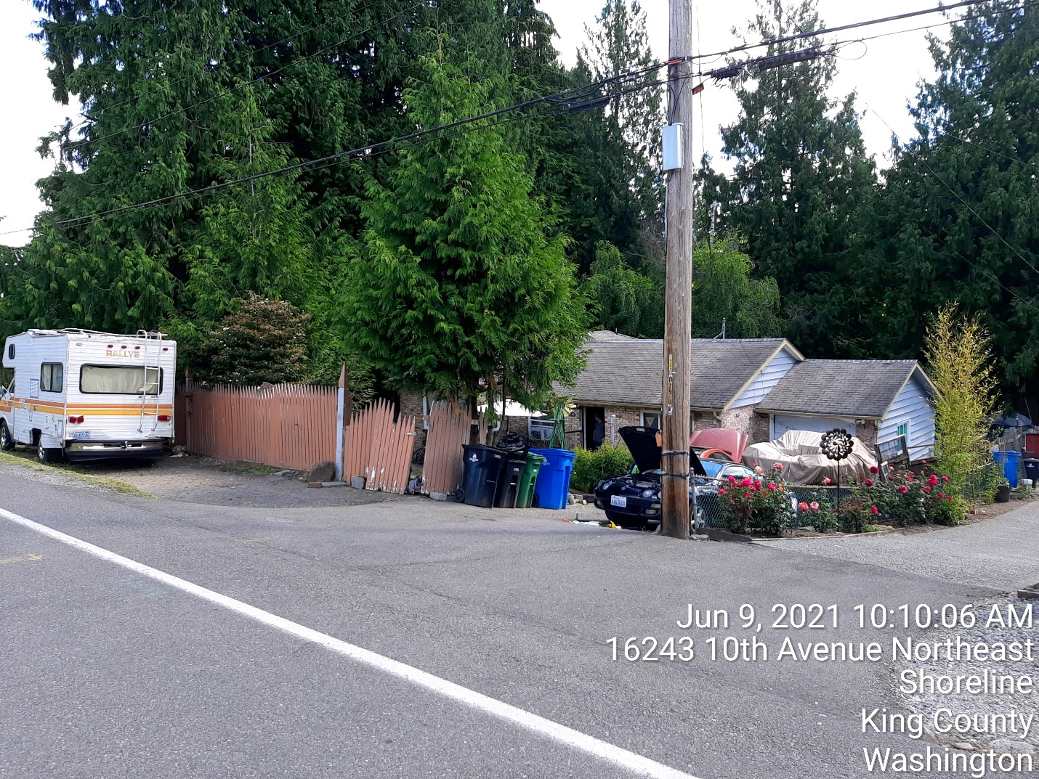
This is a street view photo from the south of the property to the north. The color of the home is Blue with a yellow trim. The home is a single-family home with a basement. Attached to the home is a single garage located on the south side of the home/lot with a single driveway that is sloped. The exterior of the home that divides the city right of way and private property is a fence. The fence in place is chain link, however attached and propped up on to the chain link fence are wooden sections of lumber (color is brown). The materials used are to limit public view to the home and are defined as refuse until properly used and constructed as a fence. The approach to the home is only through the paved driveway as the fence materials are broken, unsecured and have nails and construction materials attached that can cause harm to a person entering the property and/or working in the ROW. The homeowner obtained the materials from another home site approximately two years a brought to his home as to add move privacy.
The ROW strip located in front of the home is owned by the city, however maintained by the property owner. The property owner has altered the ROW area as to allow parking. The use of unapproved materials has been placed, removed, and replaced again for parking and is not permitted by the city as this is an unapproved parking surface. Located in the ROW is a white Dodge Rallye. The vehicle in the ROW is operational, however it was defined as being “rented” to a tenant at the time of the visit. The tenant is unwanted at the home, however will not leave the recreational vehicle after being asked to vacate the property by the homeowner. The homeowner stated that the tenant leaves debris in the ROW causing additional garbage. Additional occupants of the recreational vehicle visit the tenant. The names of the occupants are unknown and believed to have been priorly homeless before moving to the residence.
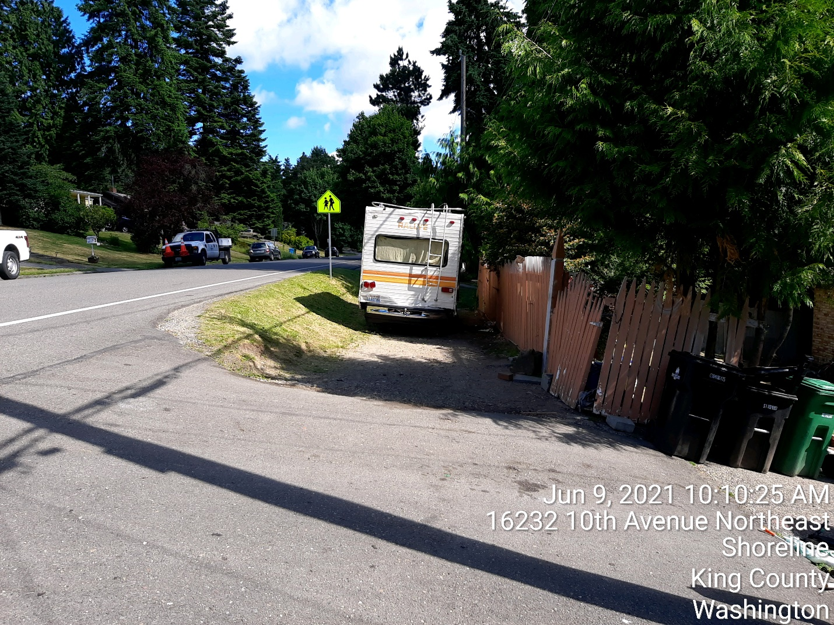
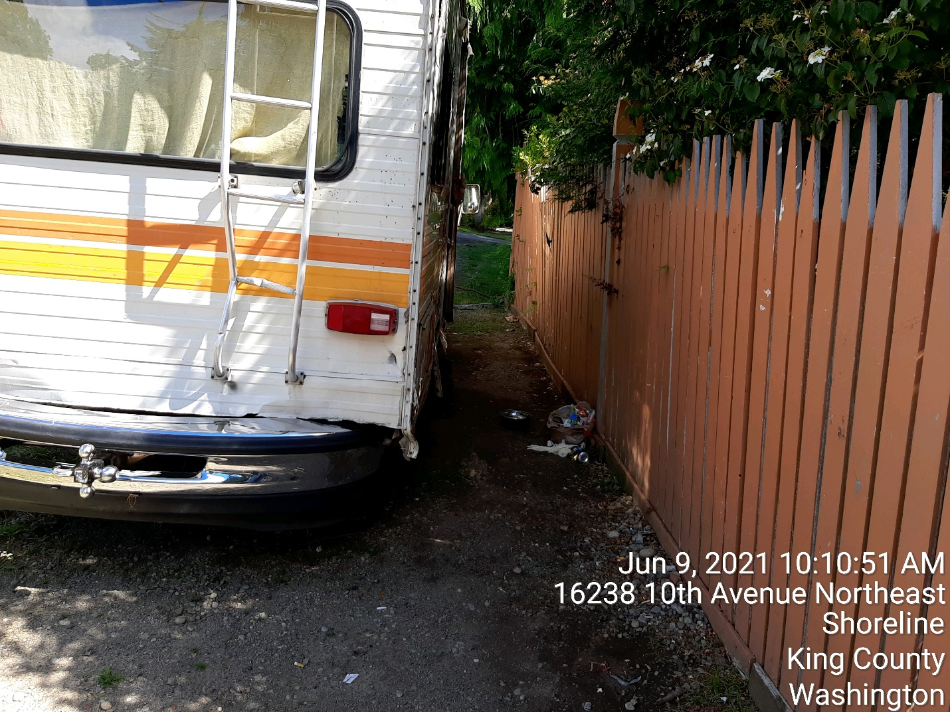
Located in the photo above is debris as defined by the homeowner as being left by the tenant of the recreational vehicle. The homeowner advised that the residence does not have garbage service. Located on-site are garbage cans, however the homeowner does not pay for garbage and refuse service due to prior lack of payments and his account has been suspended by Recology.
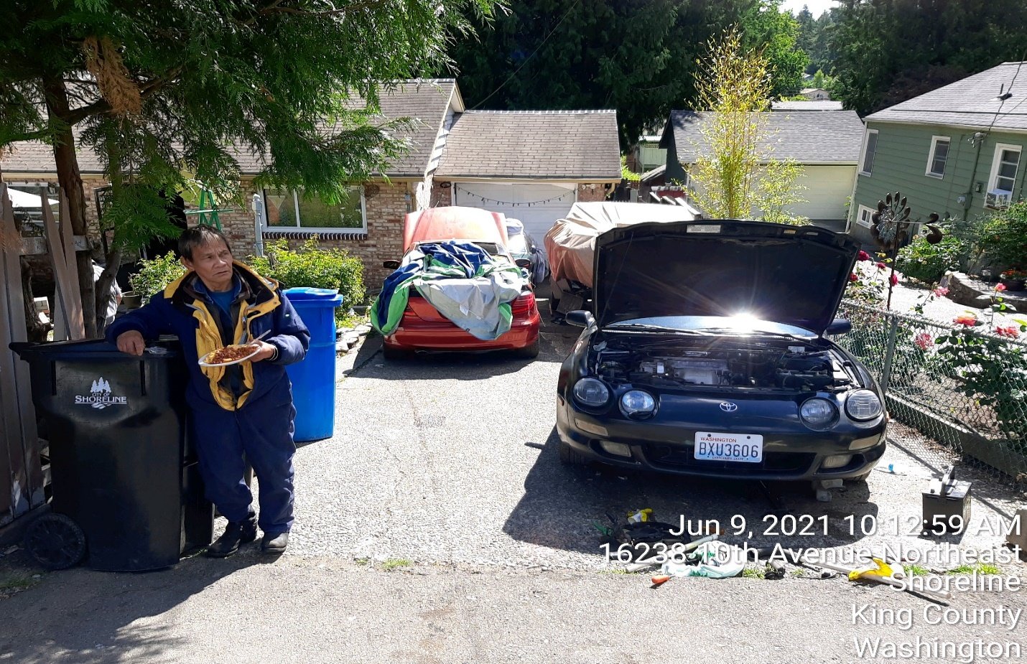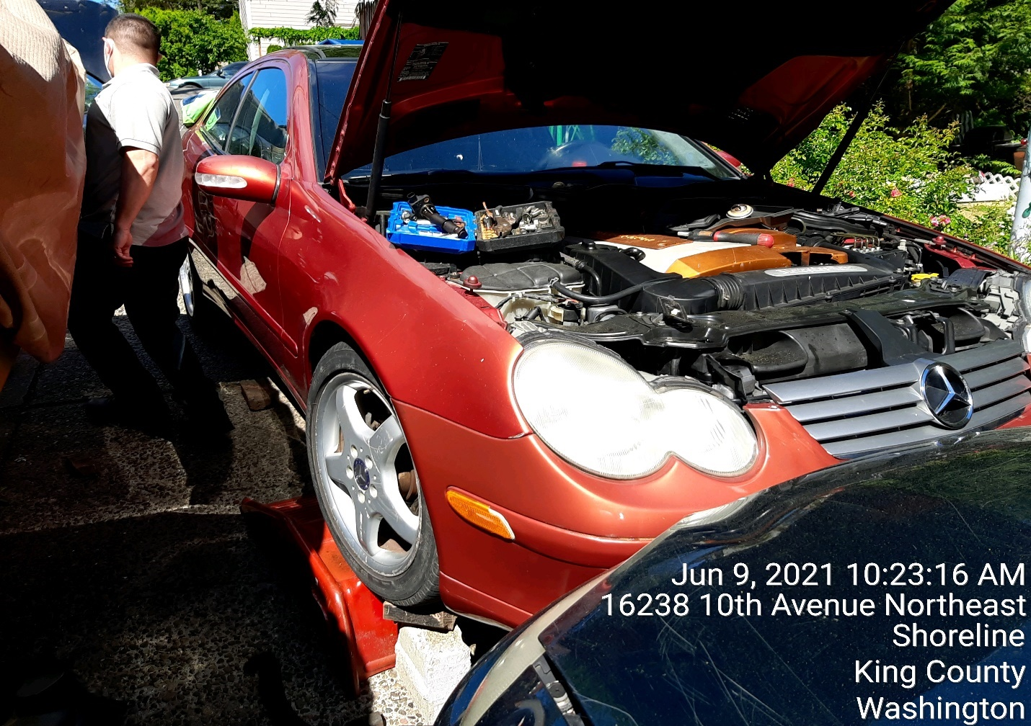
During the time of the visit the homeowner was actively working on a vehicle with an unknown man. The man was defined as a friend and tenant by the homeowner. The vehicle that was not operational at the time was a Toyota.
Also in the driveway were non-operational vehicles noted as a red Mercedes and green Mazda coupe. Both vehicles are damaged and covered with debris and/or tarps. The driveway also contains a Reinell inboard/outboard boat on a trailer. The boat is not operational and is covered by a tarp.
The driveway has motor vehicle parts lying on the ground to include radiator, car batteries and exhaust systems. Tools used to work on vehicles are also located in the driveway, much of the tools are rusted due to being left in the driveway overnight and/or in the outdoor weather environment.
The garage door is not functional and is broken. During the visit today it was closed with materials propped upon each side. During prior inspections it was reported that the garage had been occupied as a living space and storage space. I was informed that it was being used as storage space currently.
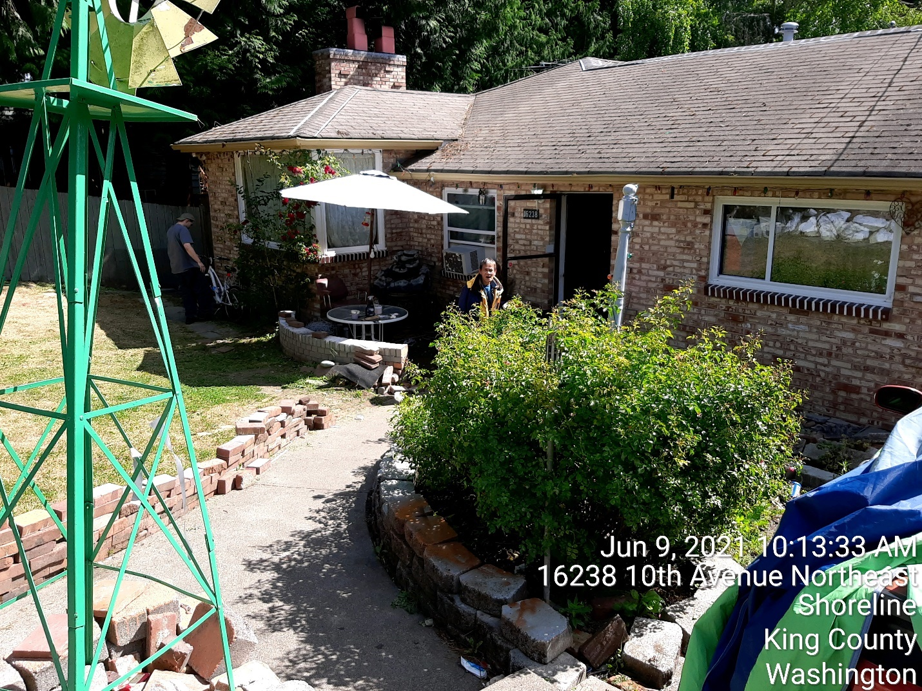
The approach to the home from the driveway is lined with stacked masonry red brick that are not secured by mortar. Some brick and landscape blocks are safely stacked and others are not. The entrance to the home is cleared and houses a decorative patio table.
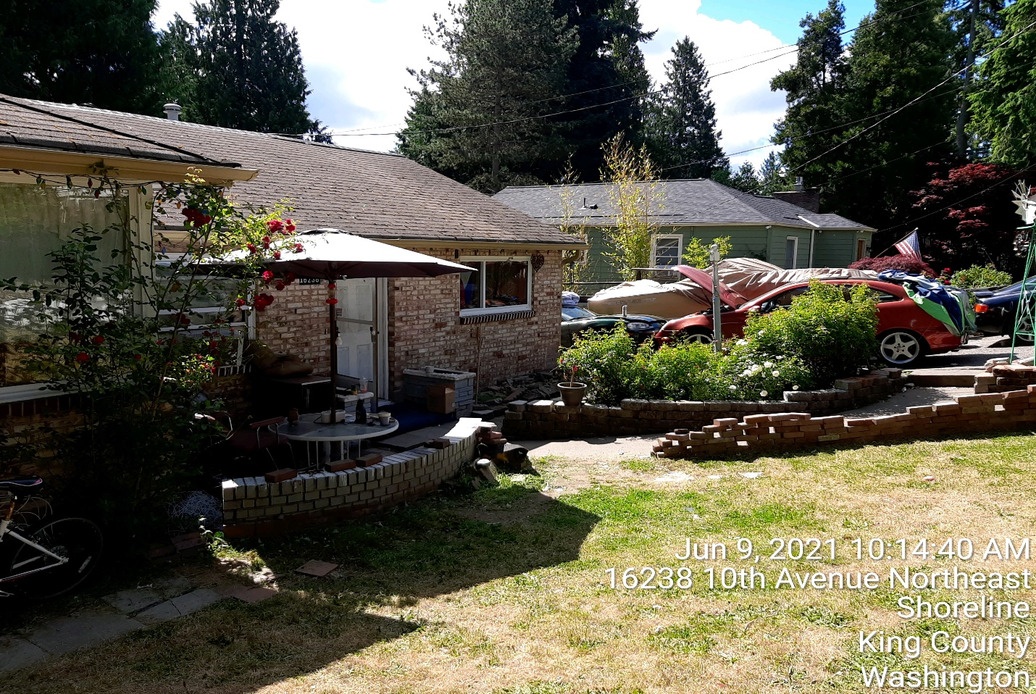
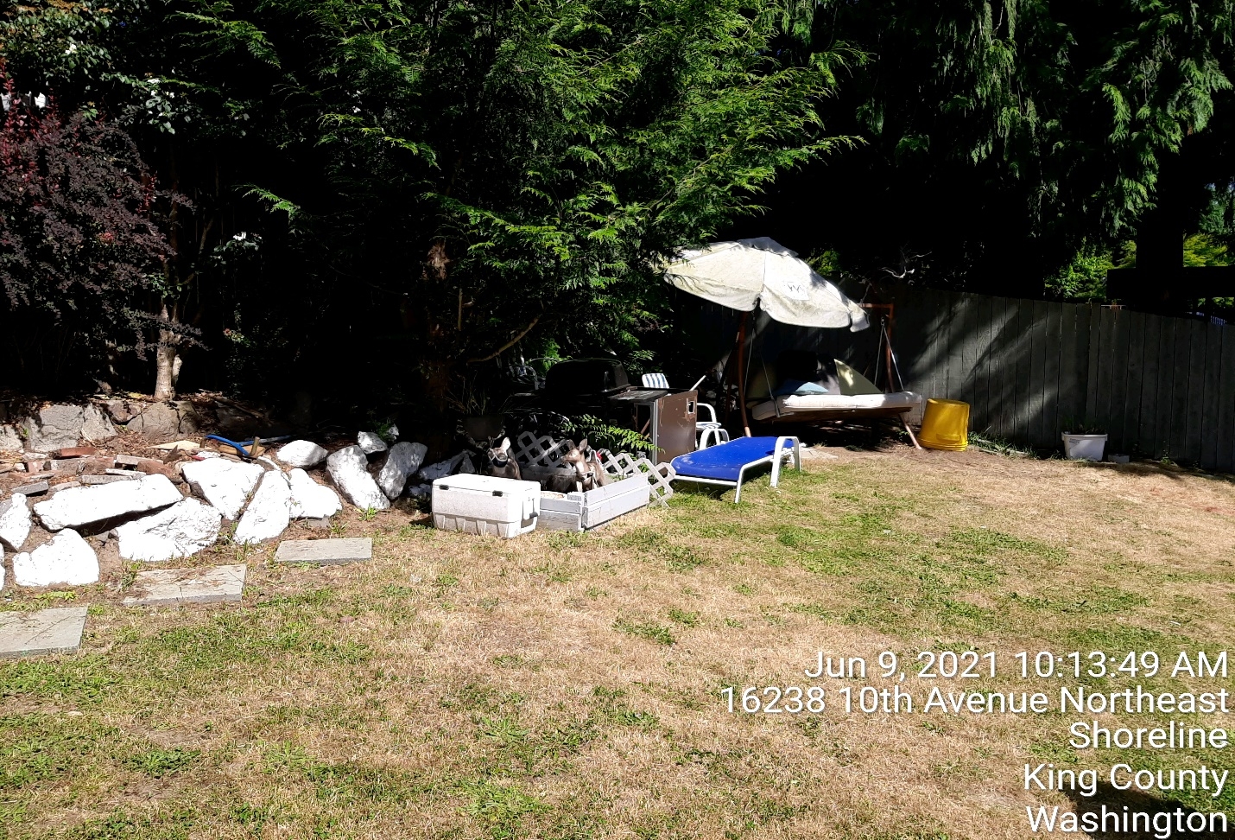
Located in the front yard is a barbeque, old rusted metal object, cooler, lawn furniture, yellow garbage cans (stacked) and outdoor living swing and patio umbrella. This area has functional items that would not be defined as refuse. It is noted that this area of the property is improved.
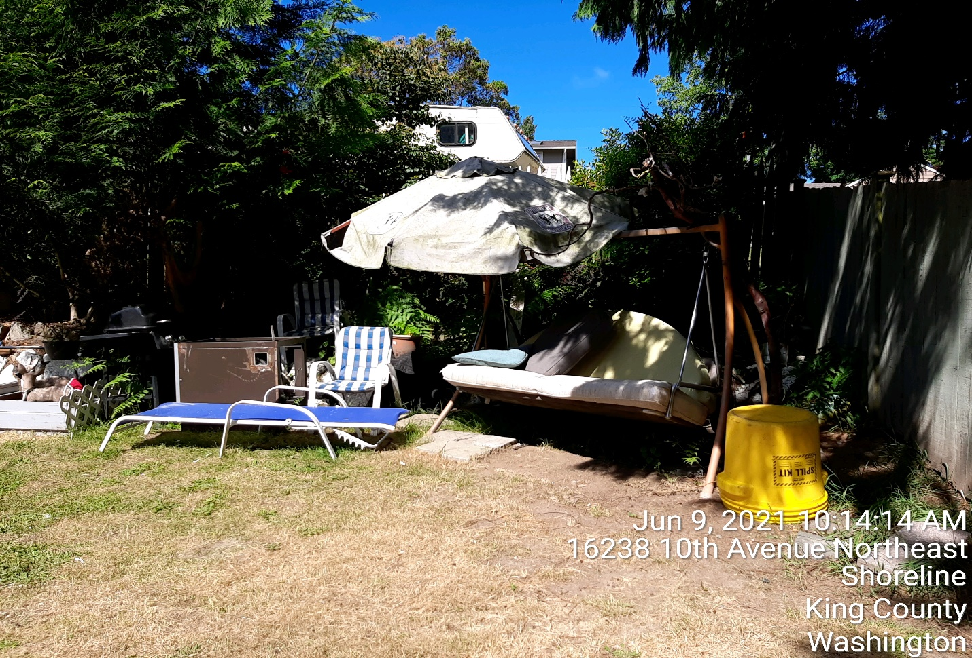
The north side of the property is fenced to separate the property from the home to the north. This area had a bike, old entrance door, steel metal grate, landscape blocks, table, tarp and window placed in the walkway. The bike was functional, however the door, metal grate and window were damaged and defined as refuse.
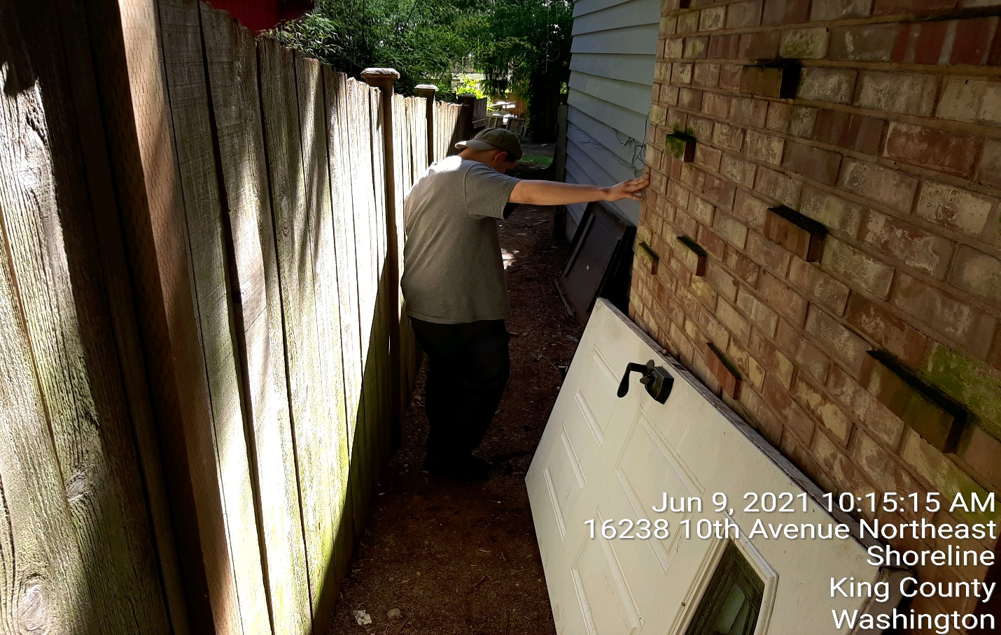

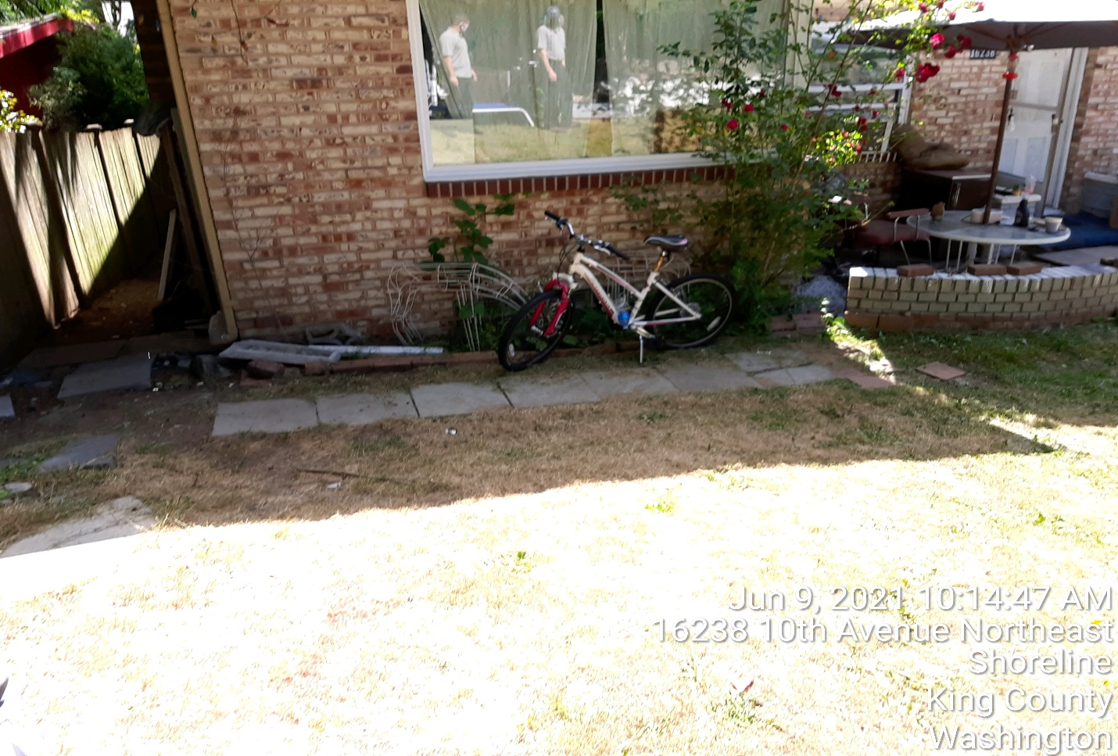
The window located on the northside of the home is broken and leads to the basement living area. This window has been broken and not repaired. I was advised that the old table in the photo was used to prop up against the broken and damaged window.
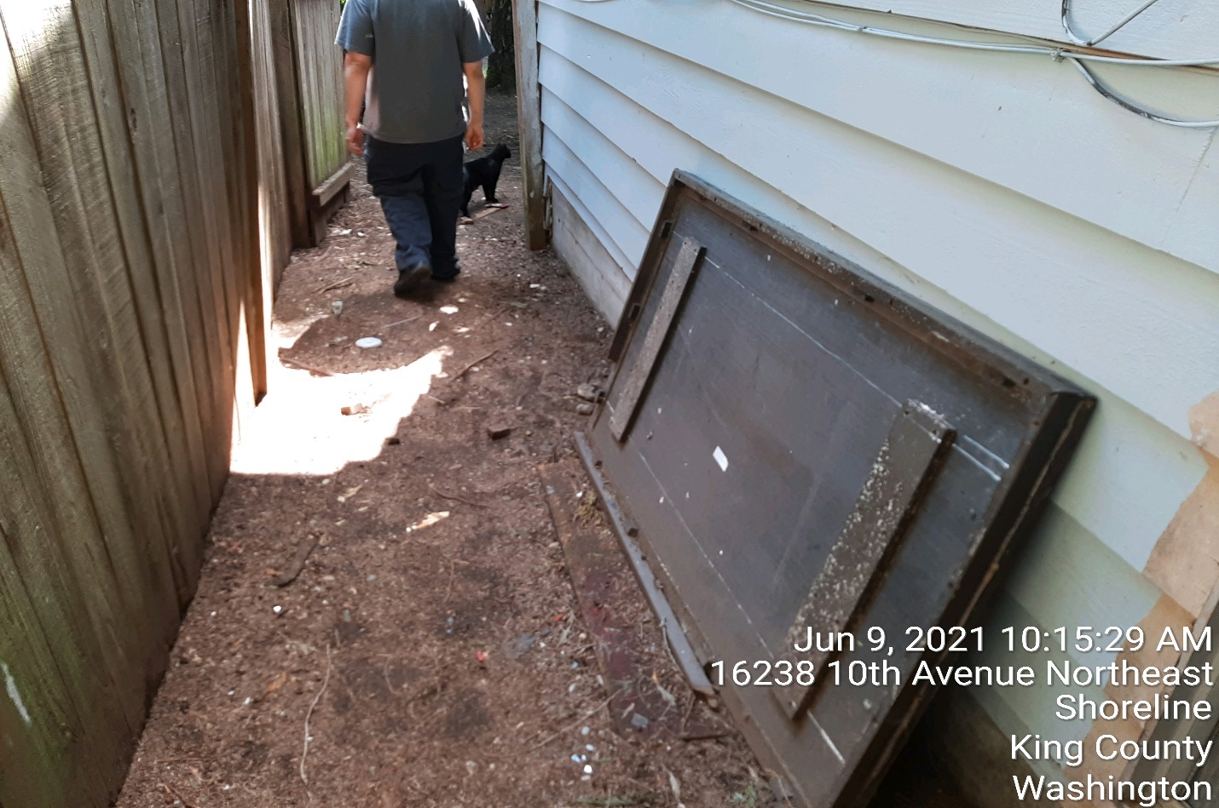
The site visit continued by entering into the backyard from the northside of the property. Upon entering the backyard the home has a deck attached to the east side of the home. The deck is raised and has storage under the deck. This area has materials that are defined as refuse.
The deck is being used as an outdoor living area for persons living at the home. You can see that there is a tent, tarps, furniture established on the deck. Rio informed me that the persons living on the deck are residents that are homeless. The names of the occupants are unknown to Rio.
Rio stated and I discussed why many people come to the home for shelter. Mental health, drug dependency and independence is a reason why occupants of the property reside at the home. I offered to have a representative come to the property to assist with both long-term and/or short-term shelter solutions. Rio advised that he did not know if the occupants would want assistance. The amount of persons believed to be living in outdoor living tents/structures at the home is believed to range from 6-10 on a consistent basis. These person’s also have people that come and visit them at the property. I did not notice any outdoor bathroom areas and was advised that most all persons that live outside have interior access to the residence as to use the bathroom and eating areas.
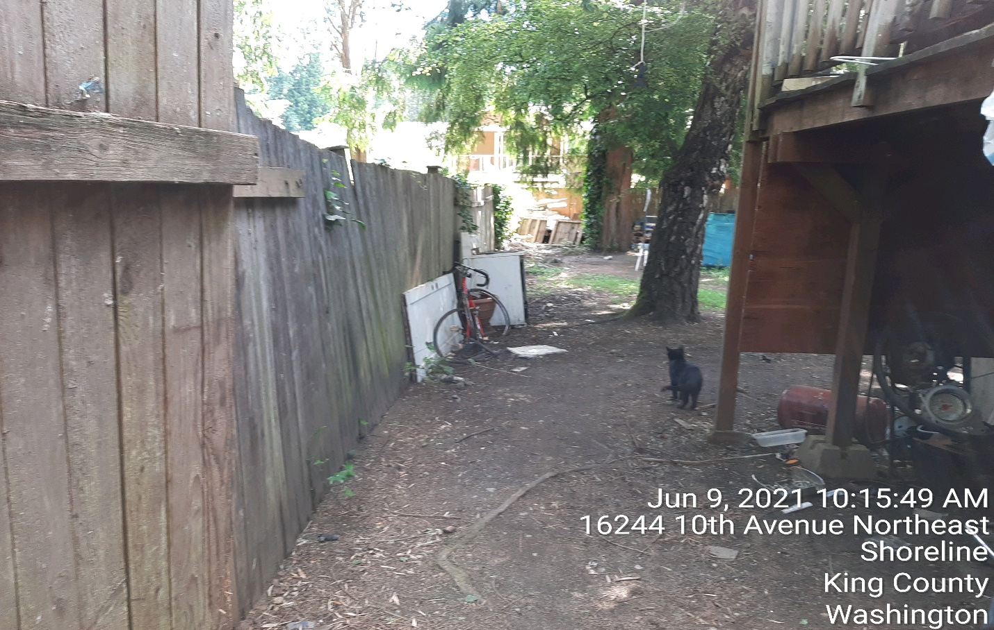
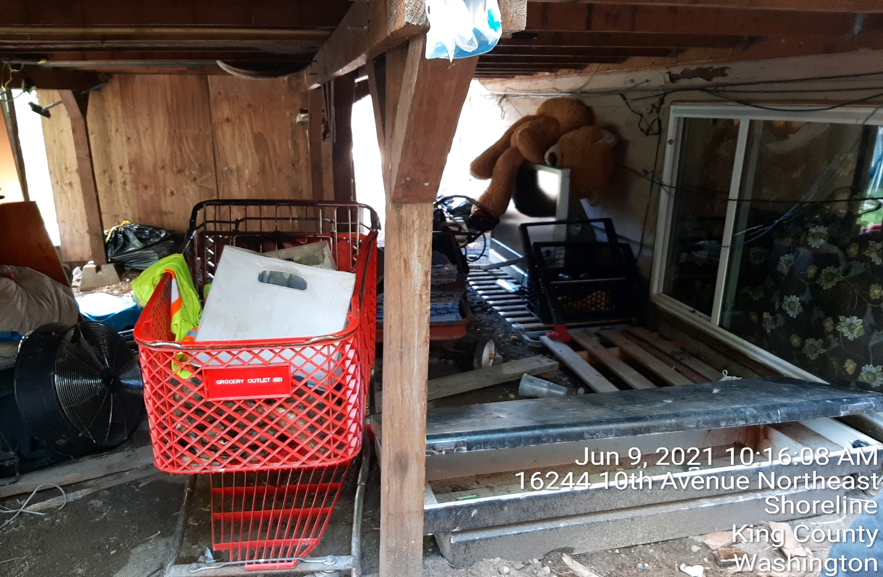
Refuse is grocery cart, kids toys, fan, garbage bags filled with refuse and unknown personal property, wood materials. The photo above is of the items under the deck. The refuse continues as the residents bring items to the home. It is noted that this area was cleaned with prior refuse vouchers provided by King County, however new materials surface with new visits.
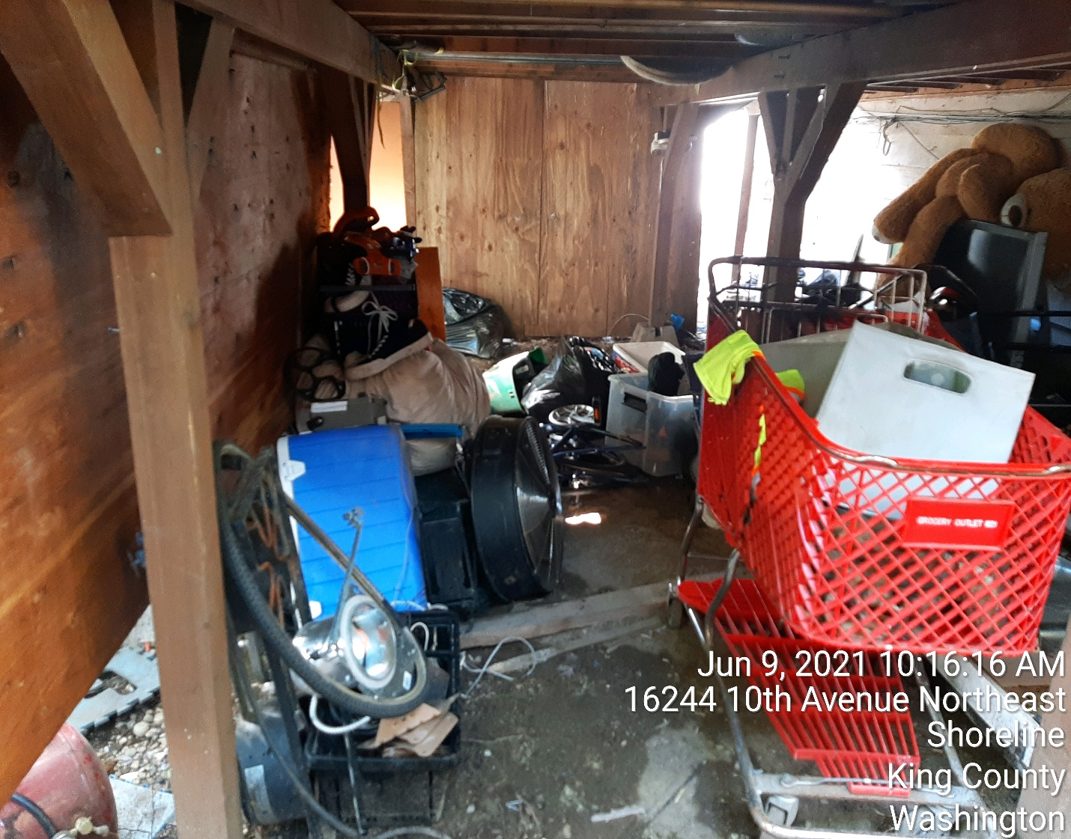
Additional items of refuse are paint cans, green metal storage locker, books, propane tanks, clothing, workout/gym equipment and tools.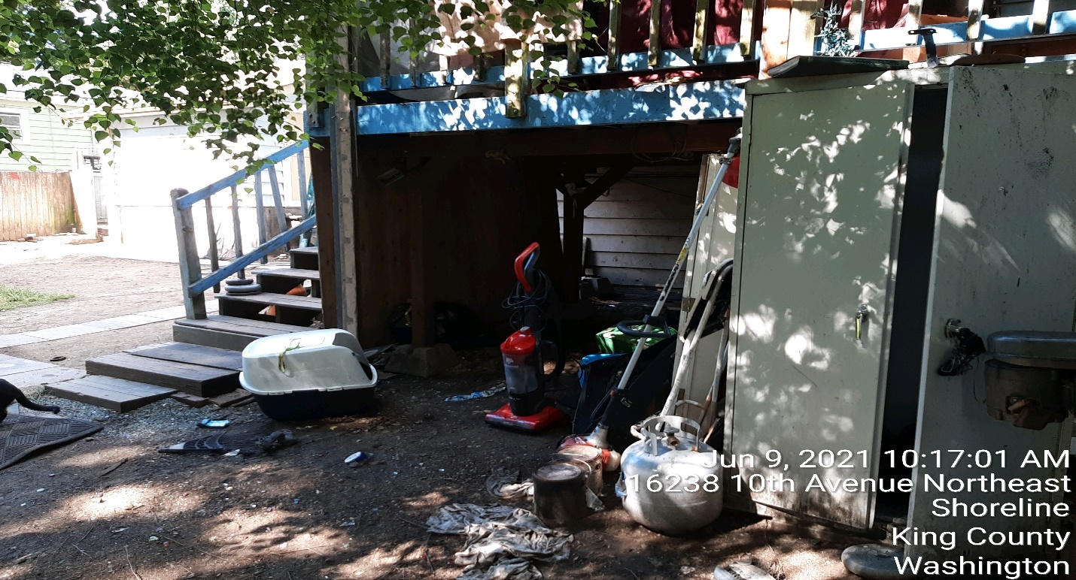The below photo is of the outdoor shelter established on the deck.
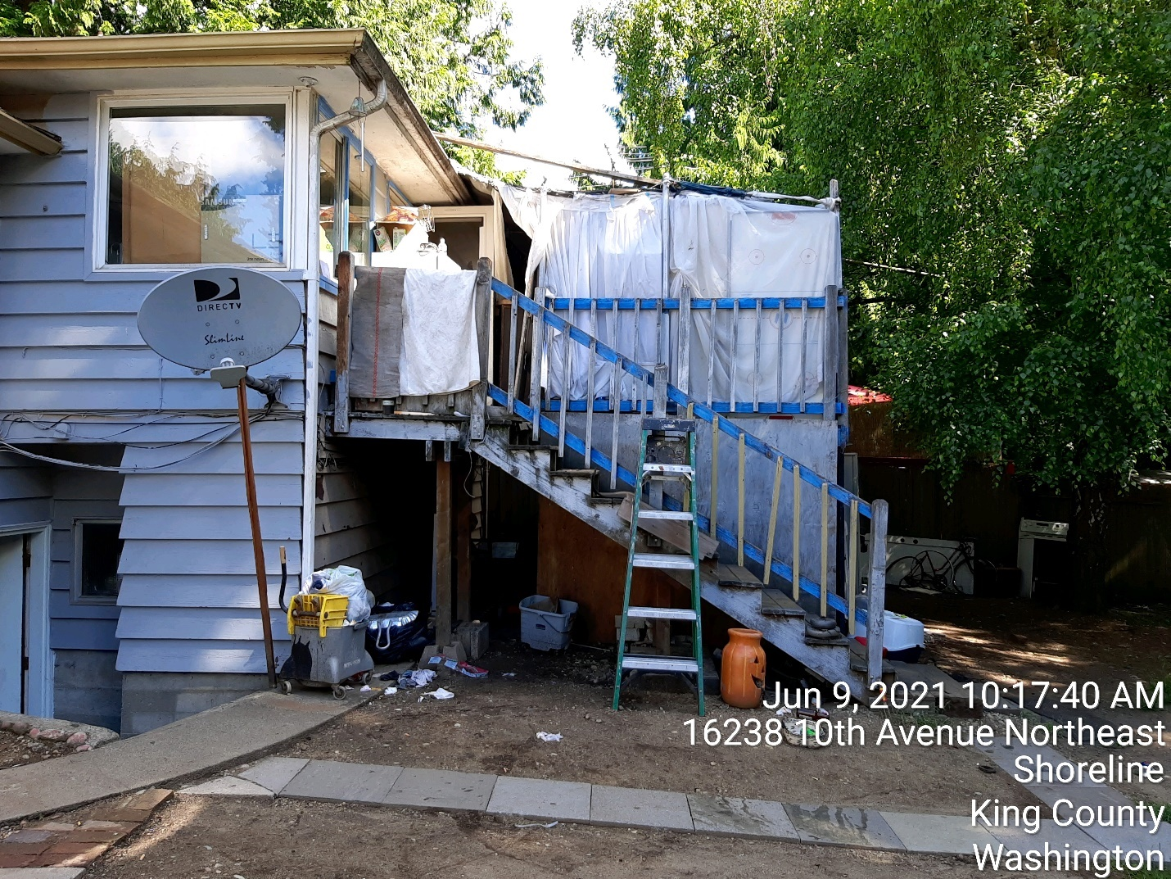
This photo shows the entrance and exit areas from the home basement and outdoor deck from the main living area of the home.
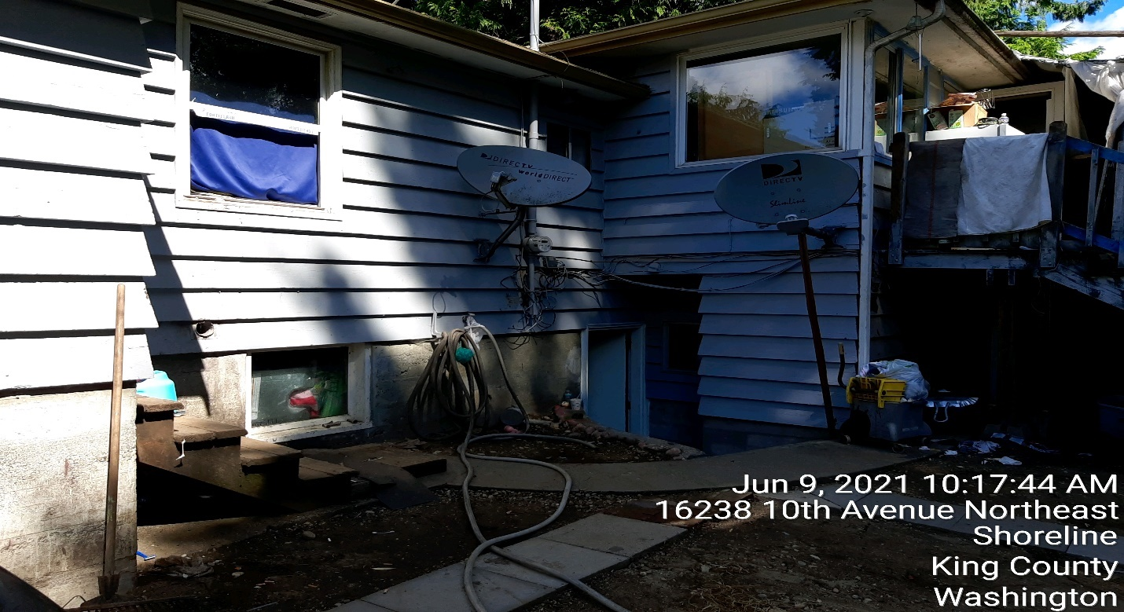
This photo is of the backside of the homes garage and the stairs that lead to the rear garage door.
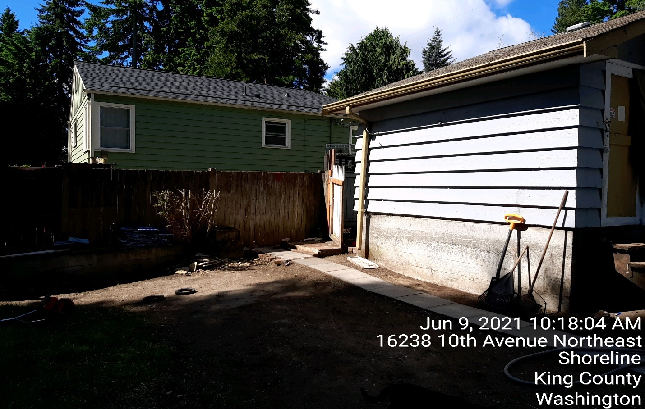

Extending into the backyard is a grass area. The grass area has a large burn pit where refuse is burned. Also in this area is an outdoor laundry line. This is the area where the Shoreline Fire Department has responded to calls for service due to burning refuse. Dividing the backyard is a large green fabric silt fence. Beyond the fence is refuse, outdoor play structure and two outdoor living areas. The green fabric fence was put in place to provide the outdoor residents more privacy from the neighbors.
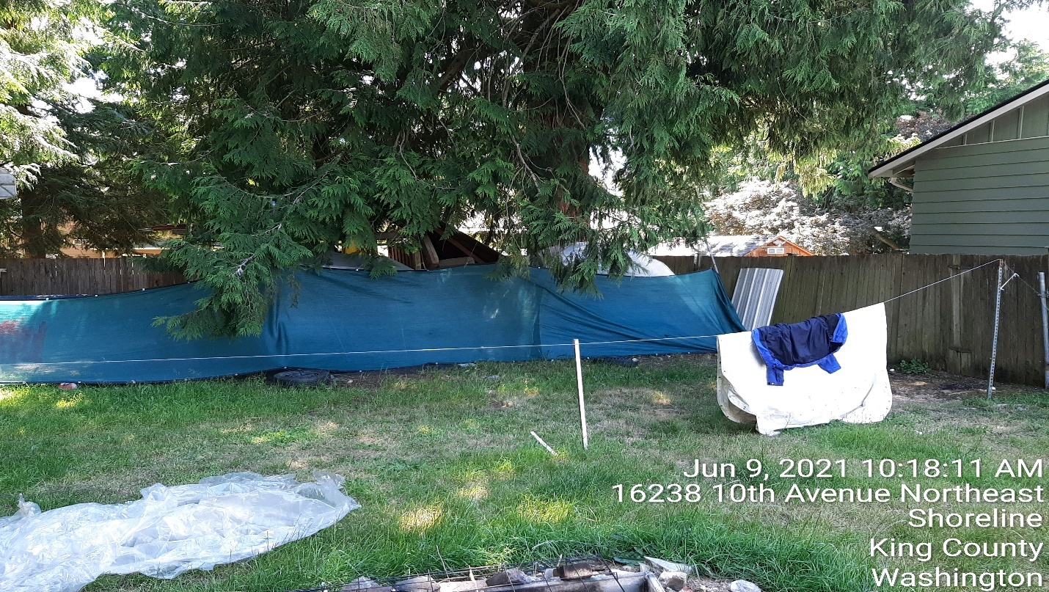
Glass, metal piping and wood materials defined as refuse.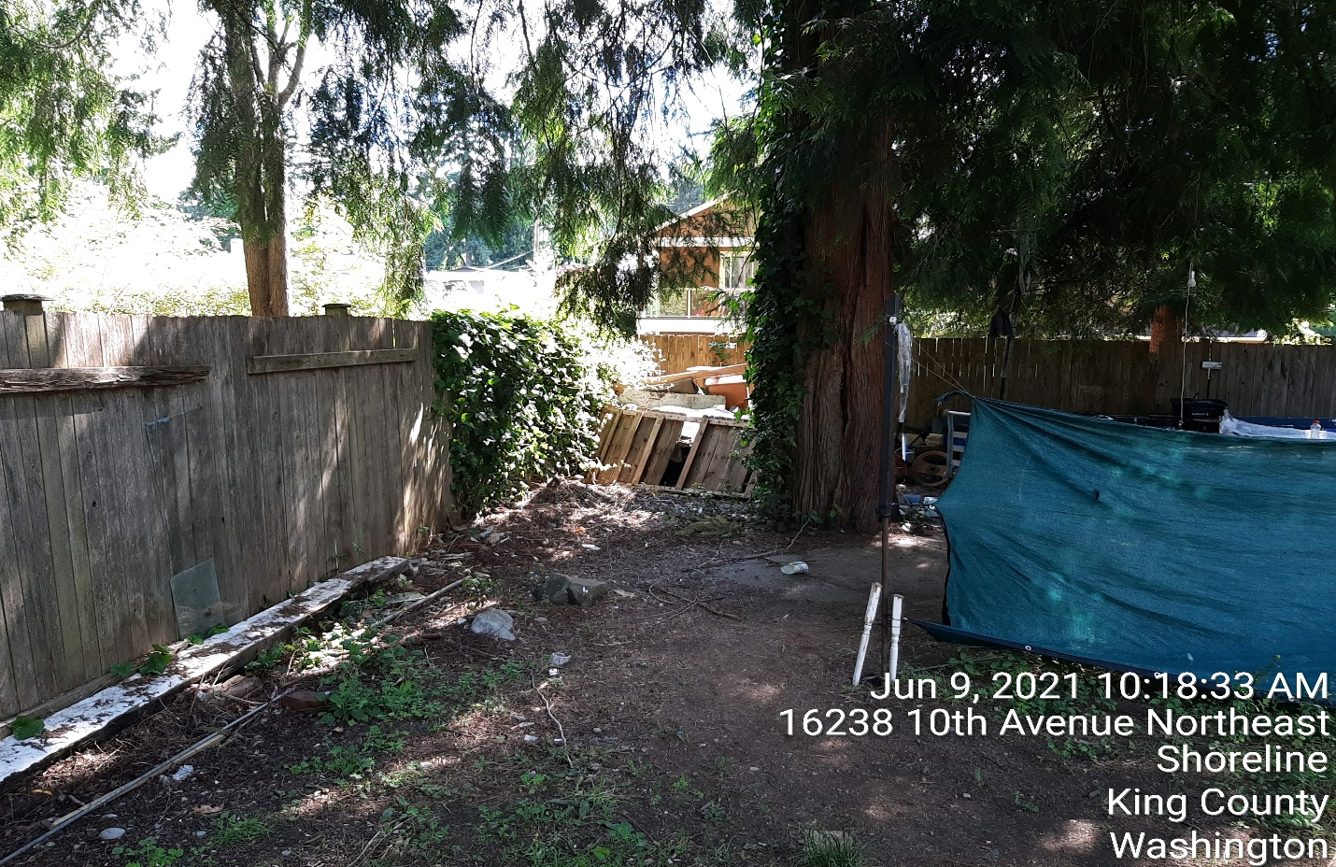
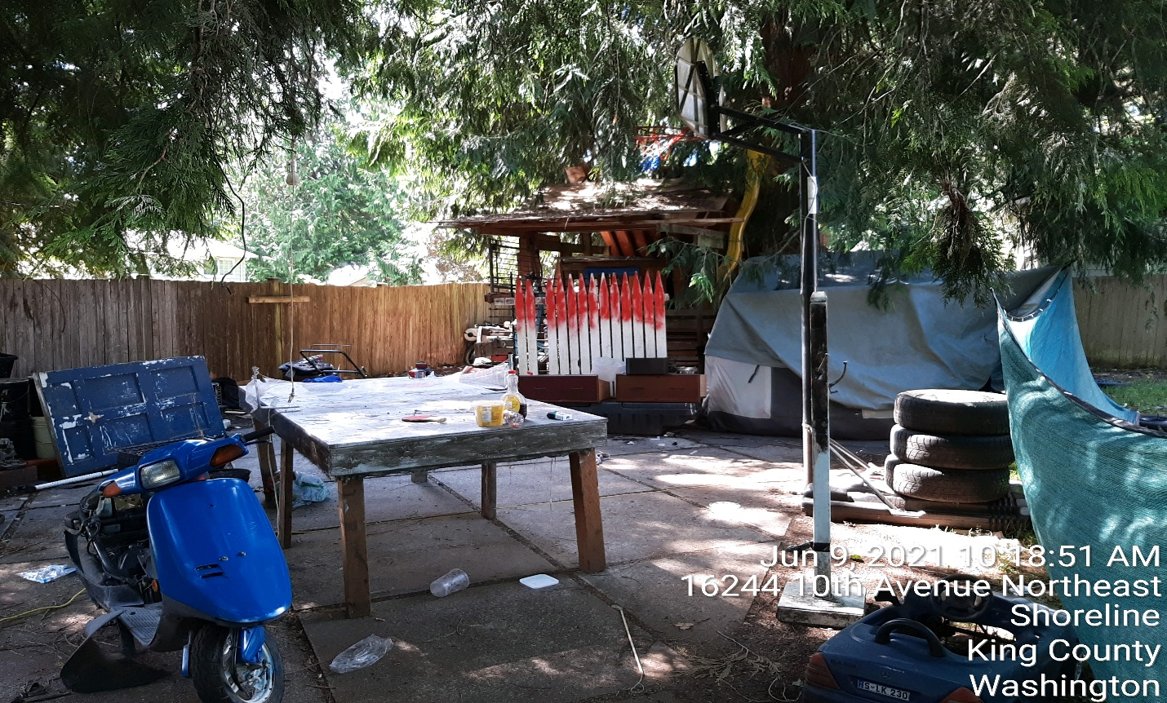
Outdoor living area near two encampments in the backyard. Old doors, tires, food refuse, wood materials, glass, kids toys, non-operational lawn mowers, motorcycles non-operational, car floor mats, chairs, construction tile, damaged furniture, kitchen appliances, paint, 5 gallon buckets, motorcycle parts.
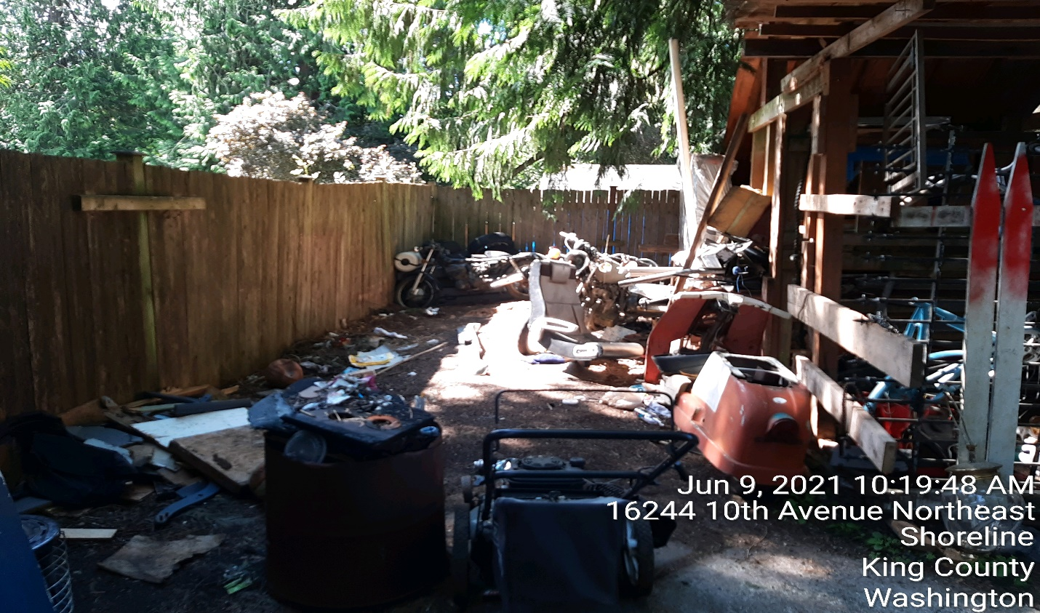
Photo below of exterior camping and living entrance. Location is South / East corner of property.
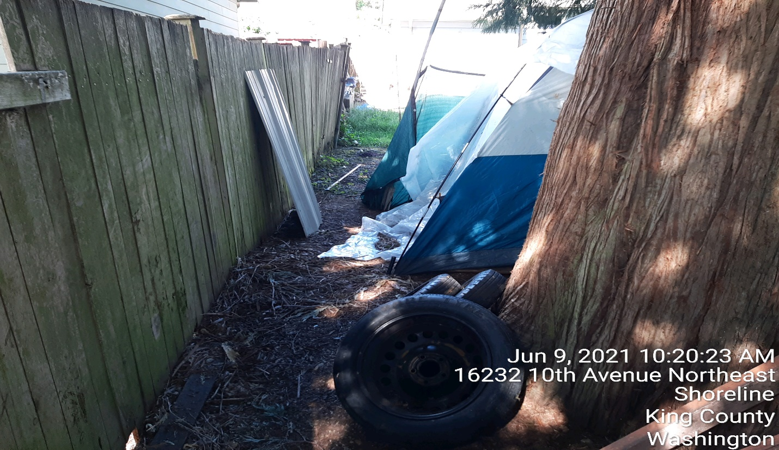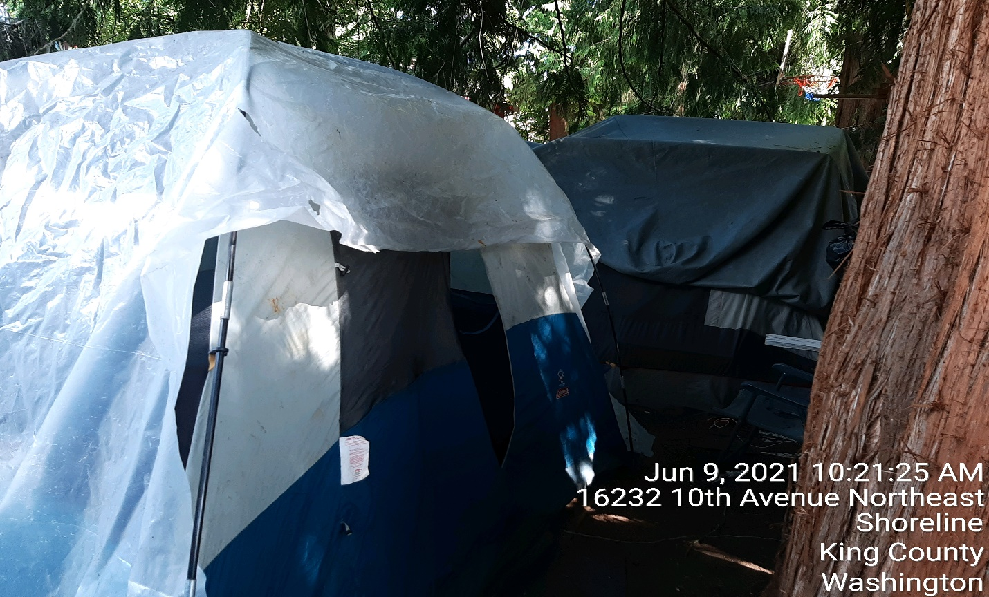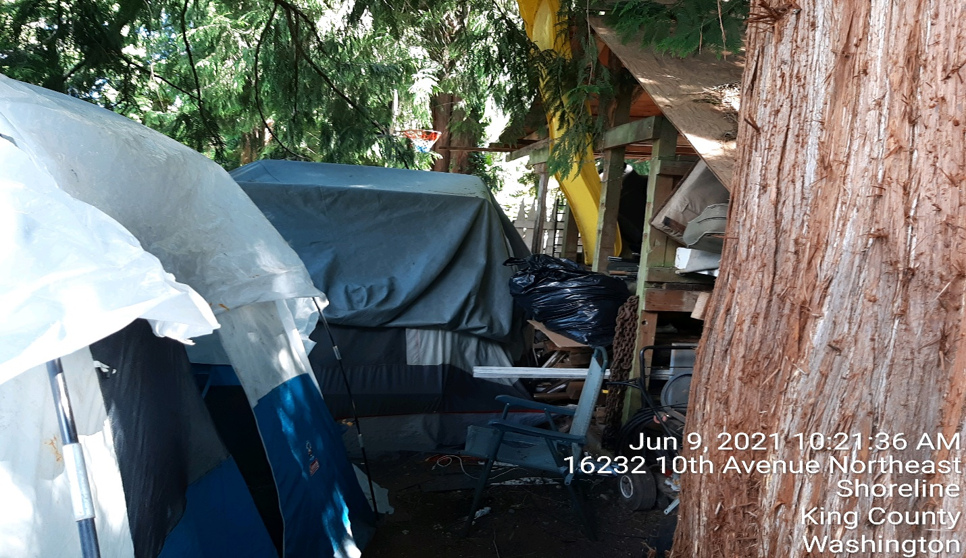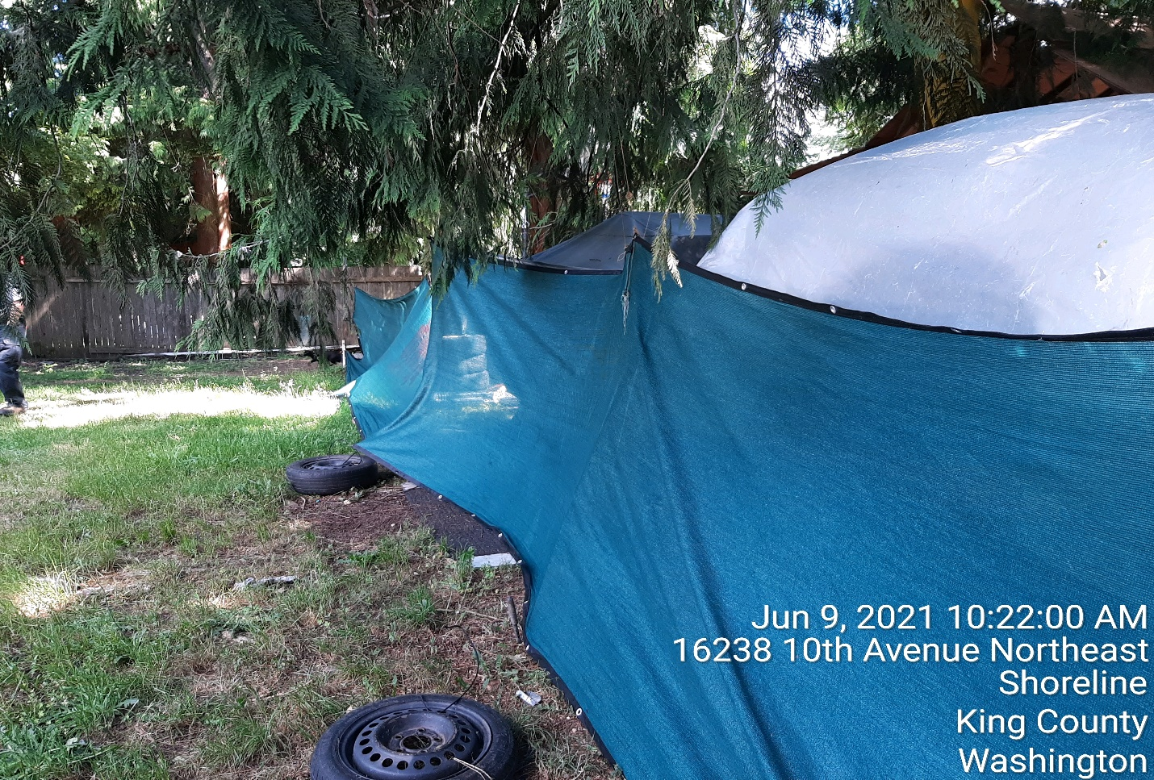
Rims, tires, debris and unknown boxes located on east fence and south fence location. 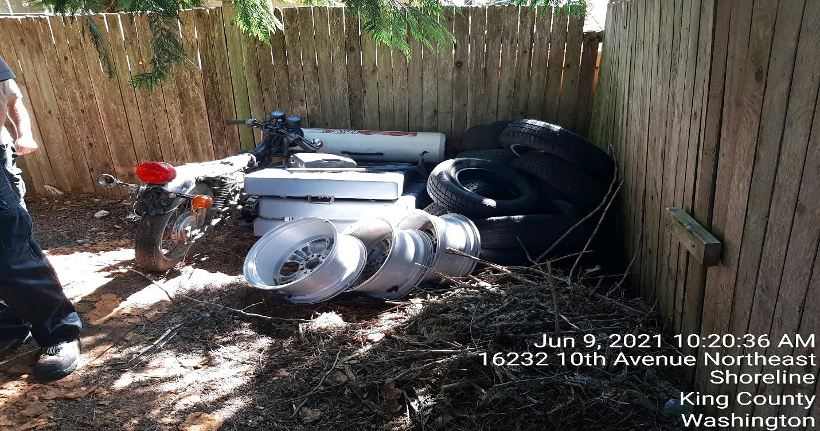
South side of the home that leads to driveway. Note that boat motor, gas tanks, propane tanks, and tarps. 